**Sales Analysis**

**High Level Design Document  
Time frame: 2010 - 2017**

|  |  |
| --- | --- |
| Written by | Nagarjuna Vijayagiri |
| Document Version | 1.0 |
| Last Revised Date | 1st March 2023 |

**Document Version Control**

|  |  |  |  |
| --- | --- | --- | --- |
| **Date Issued** | **Version** | **Description** | **Author** |
| 01st March 2023 | 1.0 | First Version of Complete HLD | Nagarjuna Vijayagiri |
|  |  |  |  |
|  |  |  |  |
|  |  |  |  |
|  |  |  |  |

**Contents**

|  |  |  |
| --- | --- | --- |
| Document Version Control | | 2 |
| Abstract | | 4 |
| 1 | Introduction | 5 |
|  | 1.1 Why this High-Level Design Documentation | 5 |
|  | 1.2 Scope | 5 |
| 2 | General Description | 6 |
|  | 2.1 Product Perspective & Problem Statement | 6 |
|  | 2.2 Tools used | 6 |
| 3 | Design Details | 7 |
|  | 3.1 Functional Architecture | 7 |
|  | 3.2 Optimization | 7 |
| 4 | KPIs | 8 |
|  | 4.1 Key Performance Indicators | 8 |
| 5 | Deployment | 8 |

**Abstract**

This project aims to provide a data-driven solution for businesses to analyse sales data and make informed decisions. The project will focus on delivering insights into sales performance, customer behaviour, product trends, and regional sales patterns. The project utilizes modern Business Intelligence (BI) tool and techniques to generate interactive dashboards, facilitating the ability to drill down into specific data points for a deeper analysis. With this information, businesses can make data-driven decisions that optimize sales strategies, improve revenue, and increase customer satisfaction. Overall, this project aims to provide a comprehensive business intelligence solution that empowers businesses to make informed decisions and stay competitive in the marketplace.

1. **Introduction**
   1. **Why this High-Level Design Document?**

A High-level design (HLD) document is a crucial document that provides a clear and concise overview of the proposed solution, outlining the project's scope, objectives, and requirements. It helps to communicate the project's architecture, design principles, and overall approach to stakeholders, including project sponsors, developers, testers, and other project team members.

The HLD will:

• Present all of the design aspects and define them in detail  
• Describe the user interface being implemented  
• Describe the hardware and software interfaces  
• Describe the performance requirements  
• Include design features and the architecture of the project  
• List and describe the non-functional attributes like:

o Security   
o Reliability  
o Maintainability   
o Portability   
o Reusability   
o Application compatibility   
o Resource utilization   
o Serviceability

**1.2 Scope**

The HLD documentation presents the structure of the system, such as the database architecture, application architecture (layers), application flow (Navigation), and technology architecture. The HLD uses non-technical to mildly-technical terms which should be understandable to the administrators of the system

**2. General Description**

**2.1 Product Perspective & Problem Statement**

Sales performance is an important reflection of the business growth, understanding of performance of range of product categories in different regions, sales channels, time frames are of great interest to business & stakeholders. The objective of the project is to perform data visualization techniques to understand the insights of the data. This project aims apply Business Intelligence tools such as Power BI to get a visual understanding of the data.

**2.2 Tools used**

Business Intelligence tool - Power BI, Excel & Power Query Editor are used to build the whole framework.

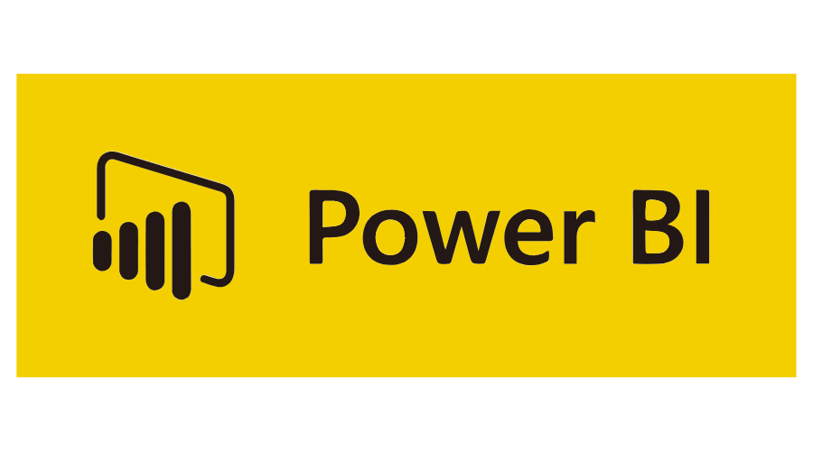 

**3. Design Details**

**3.1 Functional Architecture**

**How BI really works?**

**3.2 Optimization**

Your data strategy drives performance

1. Minimized number of fields.
2. Minimized the number of records by eliminating blank records.
3. Optimised queries by materialising the calculations.
4. Limited the filters by type.
5. Use of continuous date filter.

**4. KPIs**

Dashboards will be implemented to display and indicate certain KPIs and relevant indicators.

1. Total sales and its comparison to previous year.
2. Total Profit% and its comparison to previous year values.
3. A performance indicator table showcasing product wise performance in terms of sales, revenue & profit.

**5. Deployment**

Once the reports are created. They will be published to power Bi service using the Publish button available on the home page, for Stakeholders/Public consumption.